SHENG ZHEN AUSTIN PRESENTS
MASTER JUNFENG LI
UNION OF THREE HEARTS + SHENG ZHEN MOVEMENT
A Sheng Zhen Gong Workshop May 20 & 21, 2017
Austin, Tx

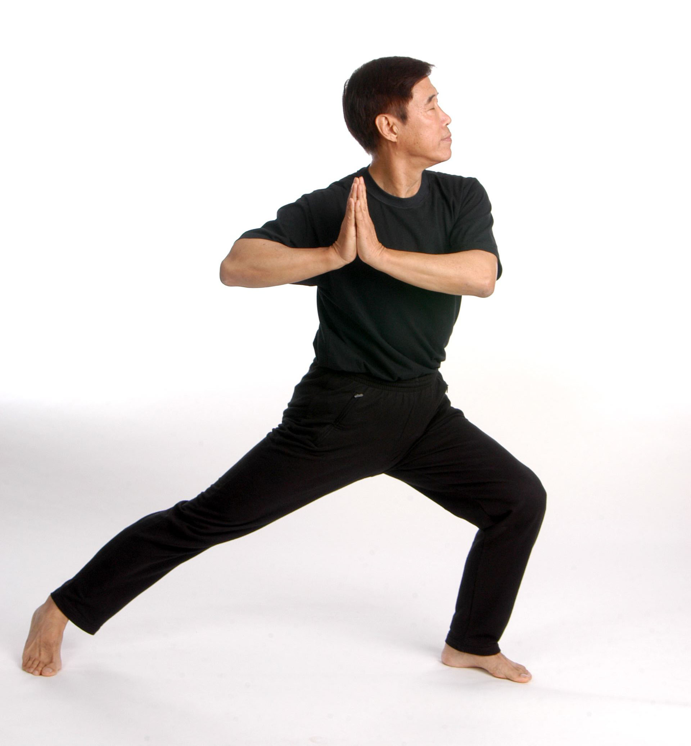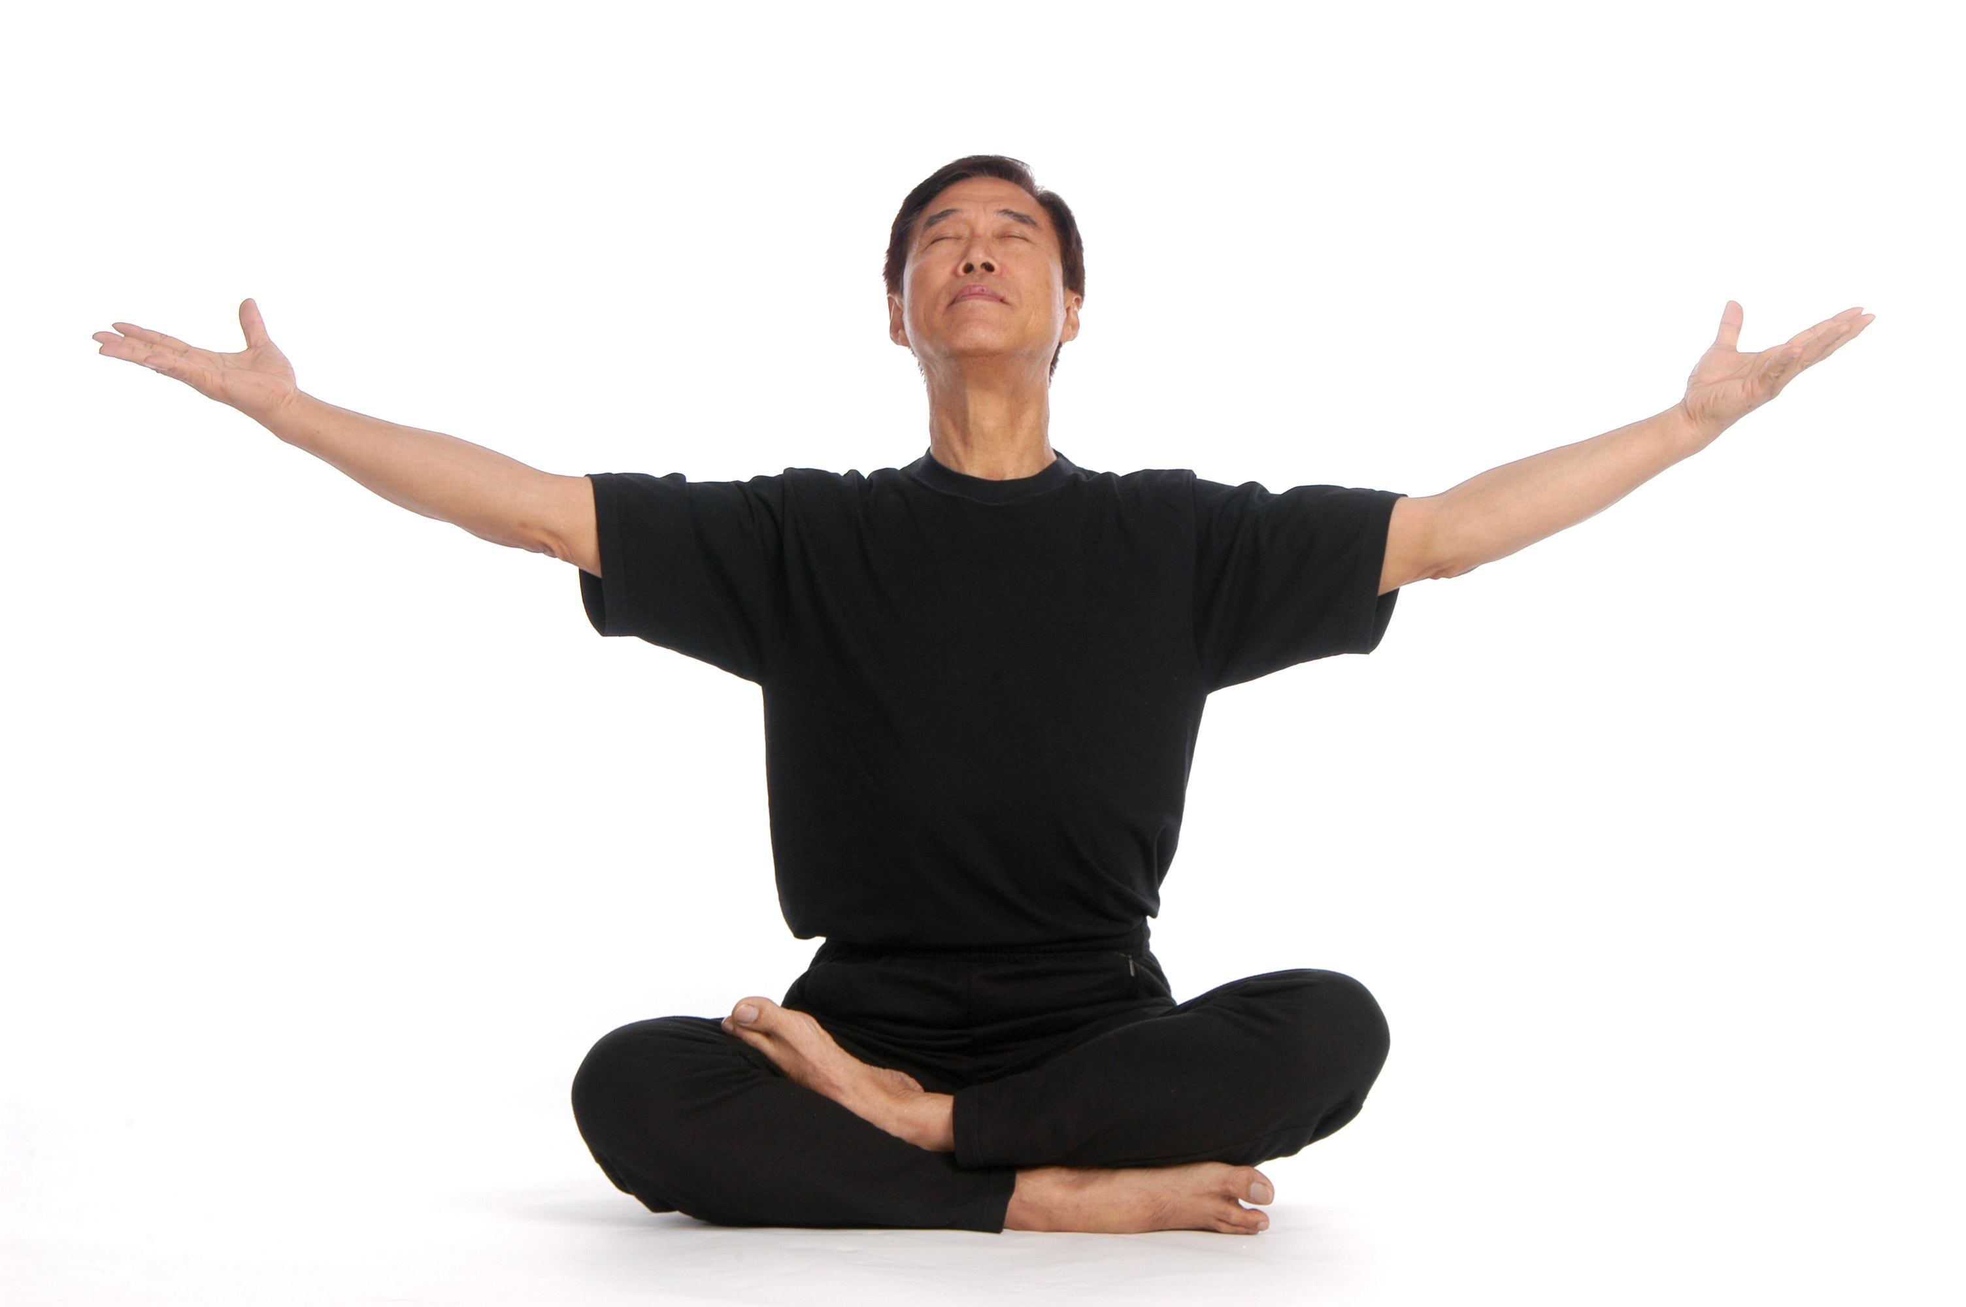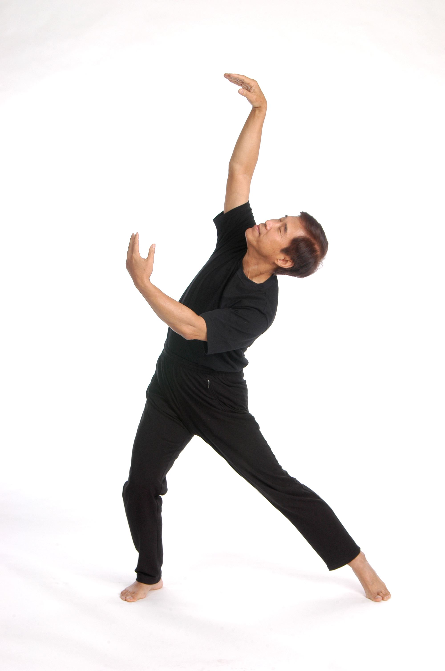

WHAT: Master Junfeng Li will be coming to Austin for a weekend workshop
of Sheng Zhen Meditation: Union of Three Hearts and Sheng Zhen movements.

WHEN: Sat May 20 and Sun May 21, 2017, 9:30 am - 5:00 pm each day

WHERE: The Ancient Yoga Center at JKP Radha Madhav Dham
400 Barsana Road, Austin, Tx 78737, http://www.ancientyogacenter-event.com/
Lodging will be available at AYC.

COST: $200 for weekend, or $125 for one day only

REGISTRATION: Francie Shimaya, shengzhenaustin@yahoo.com or 512-366-3224

SEND CHECK made payable to Sheng Zhen Austin to:
Francie Shimaya
5405 Salem Walk Drive
Austin, TX 78745

PAY BY CREDIT CARD by writing an email to shengzhenaustin@yahoo.com to receive a payment invoice.
Or bring cash at the door after receiving confirmation of registration.

